

**SECOND SEMESTER 2022-2023**

Course Handout Part II

16-01-2022

In addition to part-I (General Handout for all courses appended to the timetable) this portion gives further specific details regarding the course.

*Course No.* : EEE F246

*Course Title* : Electrical and Electronic Circuits Laboratory

*Instructor-in-Charge* : Dr. Pratyush Chakraborty

*Instructors team* : Dr. Pratyush Chakraborty, Prof. R. Venkateswaran, Dr. Syed Ershad Ahmed, Dr.

Sayan Kanungo

**Scope and Objective of the Course:** A thorough understanding of the elementary principles of Electrical and Electronics circuits and Signals and response of Systems to signals is fundamental to Electrical, Electronic and Instrumentation Engineers. This Laboratory course gives hands-on experience to the theoretical concepts covered in the theory course.

**Textbooks:**

1. Lab Manual on Microelectronic Circuits
2. Lab Manual on Signals & Systems

**Course Plan:**

The laboratory classes will be conducted in the Microelectronic Circuits and Signals and Systems Laboratories. The practicals are intended to provide hands-on experience on the concepts learned in the Microelectronic Circuits and Signals and Systems courses. Details of the experiments will be available in the “Laboratory Manual”. Laboratory marks mentioned includes marks for record and attendance in lab practical.

**List of Experiments in Microelectronics Circuits**

* 1. **Introduction to electronics laboratory: (a) Passive components (b) Measurement equipment**
  2. **P-N Junction Diode Characteristics and a Few Applications**
  3. **Performance measurement of regulated DC power supply**
  4. **Introduction to circuit simulation in LTSPICE**
  5. **Characteristics of MOSFET in common-source (CS) configuration**
  6. **Design of Regulated Power Supply & Op-amp Circuits using LTspice**
  7. **Frequency Response of common-source (CS) MOSFET amplifier**
  8. **Common Emitter BJT Transistor Characteristics**
  9. **BJT Common Base and Common Collector Characteristics**
  10. **Common Emitter Amplifier Design using LTSpice**

**List of Experiments in Signals and Systems with Matlab**

1. **Familiarization with Matlab**
2. **Matlab Exercises**
3. **Generation of Signals**
4. **Signal operations (scaling, shifting, inversion)**
5. **Synthesis of signals using Fourier Series**
6. **Convolution**
7. **Laplace Transforms**
8. **Sampling and Reconstruction**
9. **Generation of Spectrum of signals Using FFT**
10. **Analog Filters**

Evaluation Scheme:

|  |  |  |  |  |
| --- | --- | --- | --- | --- |
| **Component** | **Durati on** | **Weightage (%)** | **Date & Time** | **Nature of Component** |
| Laboratory Practical Regular class work | 4 hours/ week | 40% | Regular lab Performance | Open Book |
| Quiz/Assignment/Term Paper/Lab Bench Test |  | 60% | Will be announced | Closed Book |

**Chamber Consultation Hour:** Chamber consultation hours of Instructors will be announced separately.

**Notices:** All notices of this course will be displayed in CMS

**Make-up Policy:** One Lab Make-up will be granted for genuine reasons, only when prior-permission is obtained from Instructor-in-charge.

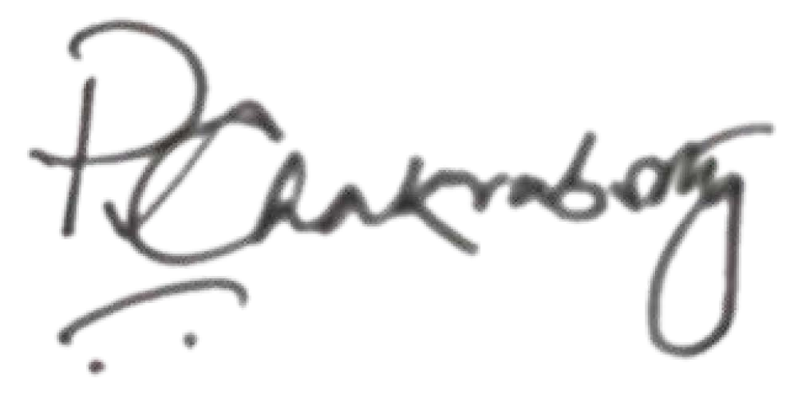**Academic Honesty and Integrity Policy:** Academic honesty and integrity are to be maintained by all the students throughout the semester and no type of academic dishonesty is acceptable.

**INSTRUCTOR-IN-CHARGE**